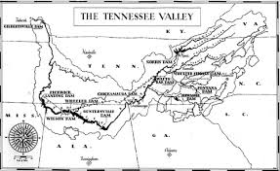

**Do You Want A Steady Income?**

**Then JoinThe TVA Today!**