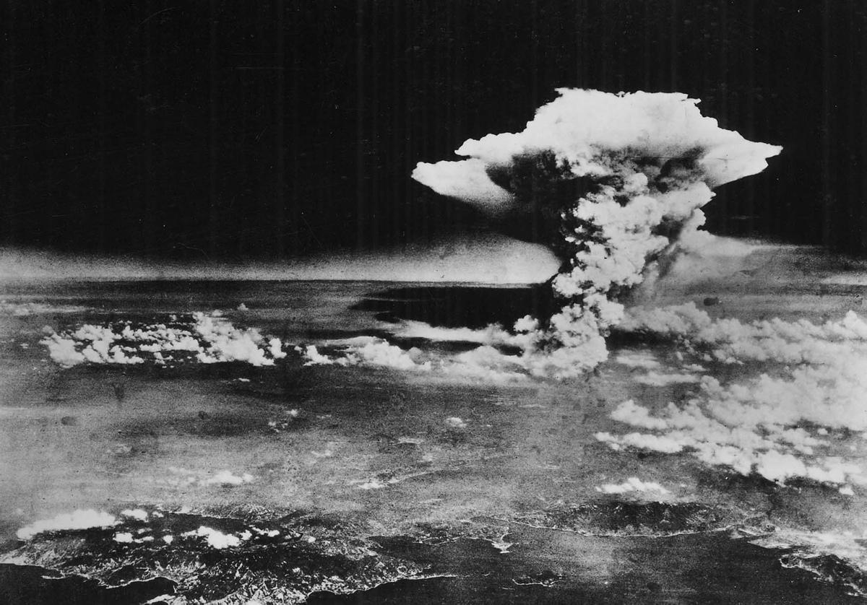

Why Would Anyone Be Against That

Be Against That

**This Saved Your Son, Your Firend, Your Coworker**